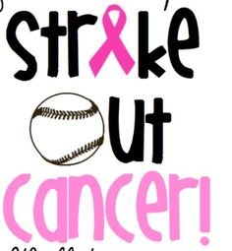
Breast Cancer Awareness
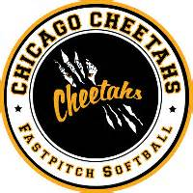
11u / 12u Open Round Robin
Date: Sunday: October 22, 2017 (9:00 AM Start)
Location: Powers Park
6501 Springside Ave, Downers Grove, IL 60516

Fee: $225 (Checks Payable to Chicago Cheetahs)
Portion of Proceeds will go to American Cancer Society to Help Fight Breast Cancer
Facts:
- ASA rules with free substitution
- MVP Medals each game
- 80 minute no new inning, 90 minute drop dead
- 3 game guarantee (weather permitting – one game constitutes a tournament)
- In the event of Rain Out $50.00 administrative fee will be applied
- 12 team max
Team Name:
Manager Name:
Address:
Email address:
Checks payable to the Chicago Cheetahs should be sent to
Chicago Cheetahs
495 Bloomfield Circle West
Oswego, IL 60543
Each Team Must provide Proof of Insurance and ASA, PGF or USSSA Roster Upon Check In

